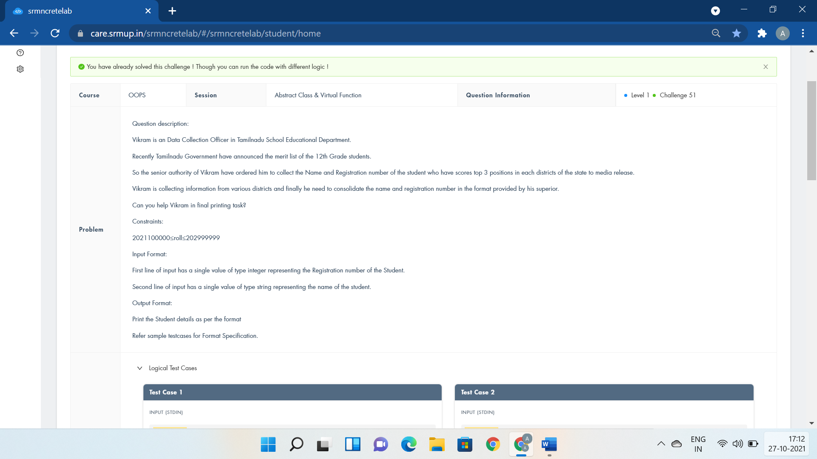

#include <iostream>

using namespace std;

class School{

public:

int roll;

string name;

virtual void getdata(){};

virtual void display(){};

};

class District : public School{

void getdata();

void display();

};

void District :: getdata(){

cin>>roll>>name;

}

void District :: display(){

cout<<"Student Name is: "<<name<<endl<<"Student Roll no is: "<<roll;

}

int main()

{

District obj;

School\* ptr;

ptr = &obj;

ptr -> getdata();

ptr -> display();

return 0;

}

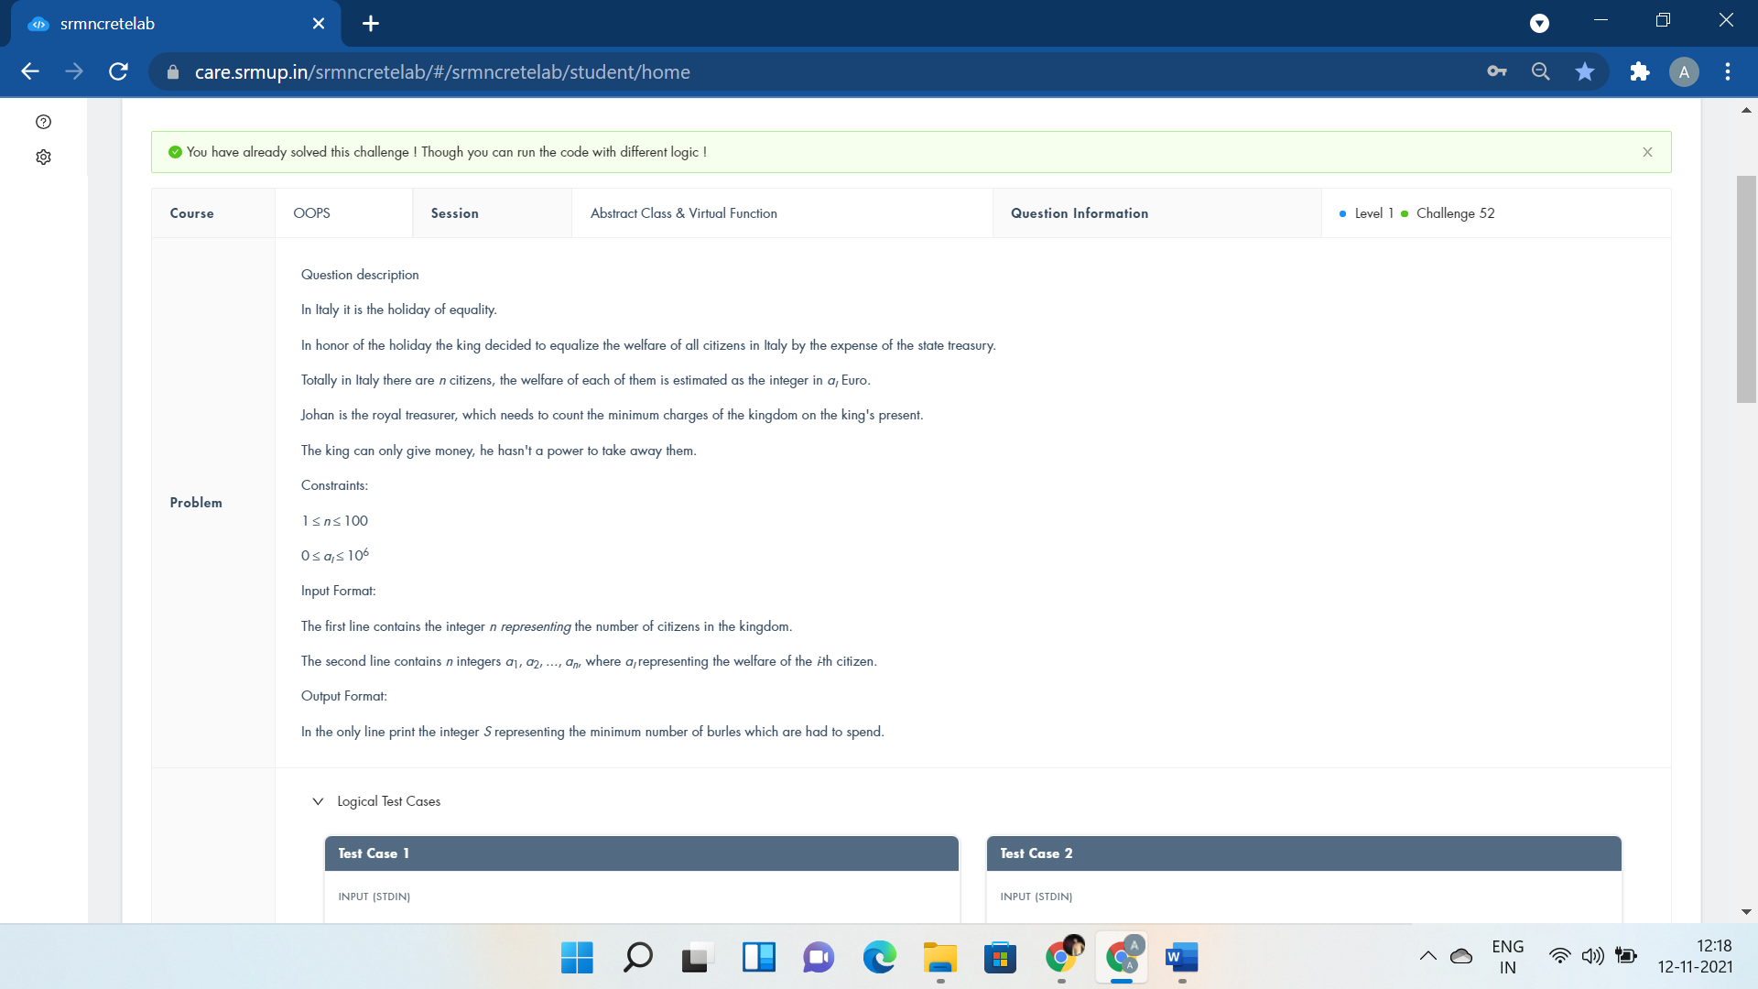

#include <bits/stdc++.h>

using namespace std;

int a,b,c,d,i;

class Holiday{

public:virtual void Expenses()=0;

};

class Citizen:public Holiday{

public:

void Expenses(){

cin>>c;

for (i=0; i<c; i++){

cin>>a;

if (d<a) d=a;

b=b+a;

}

cout<<d\*c-b;

}

};

int main (){

Citizen obj;

obj.Expenses();

return 0;

}

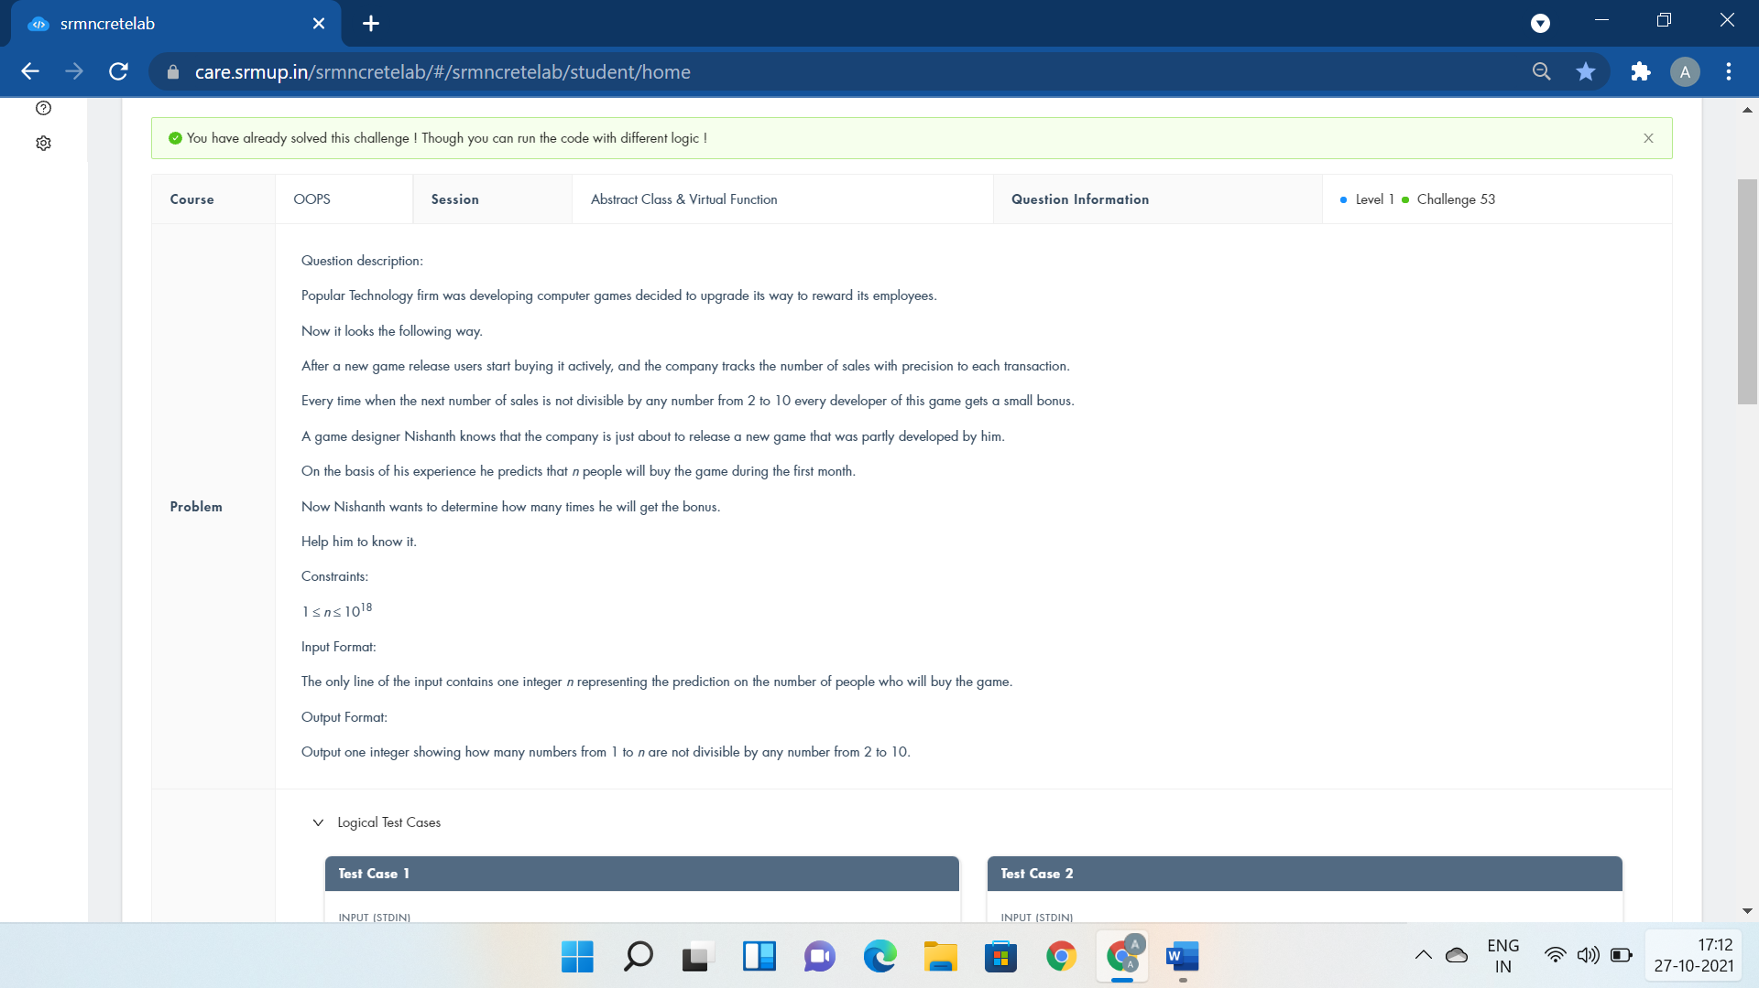

#include <bits/stdc++.h>

using namespace std;

class Employees{

public:virtual void BuyingGame()=0;

};

class Reward:public Employees{

public:

int n;

void BuyingGame(){

cin>>n;

cout<<n - n / 2 - n / 3 - n / 5 - n / 7

+ n / 6 + n / 10 + n / 14 + n / 15 + n / 21 + n / 35

- n / 30 - n / 42 - n / 70 - n / 105 + n / 210;

}

};

int main()

{

Reward obj;

obj.BuyingGame();

return 0;

}

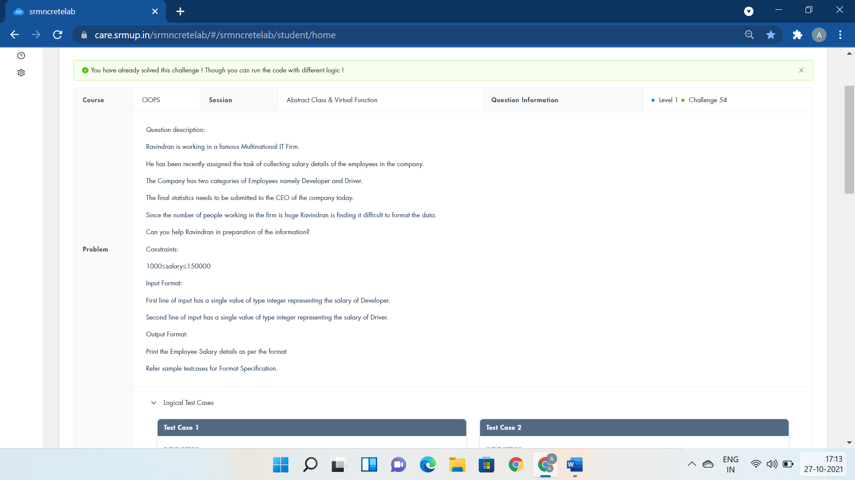

#include <iostream>

using namespace std;

class Employee{

public:

int s1,s2;

};

class Developer : public Employee{

public:

void getSalary(){

cin>>s1;

cout<<"Salary of Developer:"<<s1<<endl;

}

};

class Driver : public Employee{

public:

void getSalary(){

cin>>s2;

cout<<"Salary of Driver:"<<s2<<endl;

}

};

int main()

{

Developer d1;

Driver d2;

d1.getSalary();

d2.getSalary();

return 0;

}

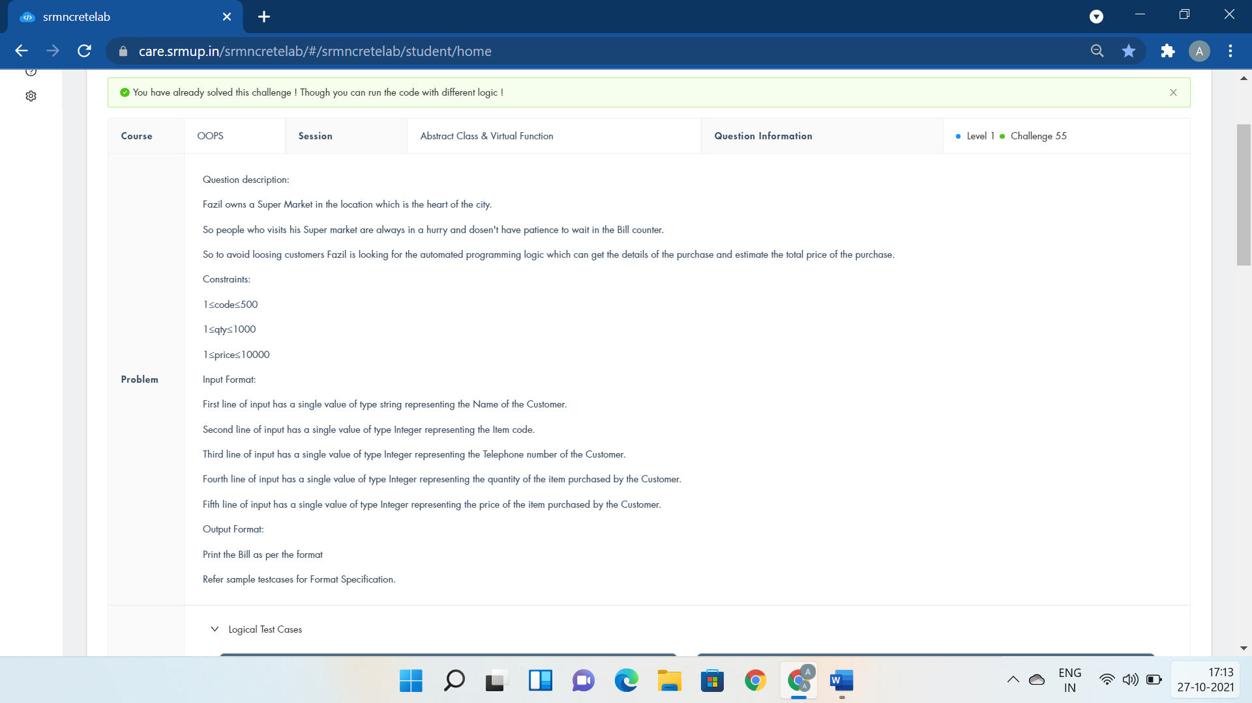

#include <iostream>

using namespace std;

class consumer{

public:

string name;

virtual void getdata()=0;

virtual void display()=0;

};

class transaction: public consumer{

public:

int code;

long tel;

int quan,price;

void getdata(){

cin>>name>>code;

cin>>tel;

cin>>quan;

cin>>price;

}

void display(){

cout<<"Name : "<<name<<endl<<"Code : "<<code<<endl<<"Telephone : "<<tel<<endl;

cout<<"Quantity : "<<quan<<endl<<"Price : "<<price<<endl<<"Total Price : "<<quan\*price<<endl;

}

};

int main()

{

consumer\* o1;

transaction o2;

o1=&o2;

o1->getdata();

o1->display();

return 0;

}

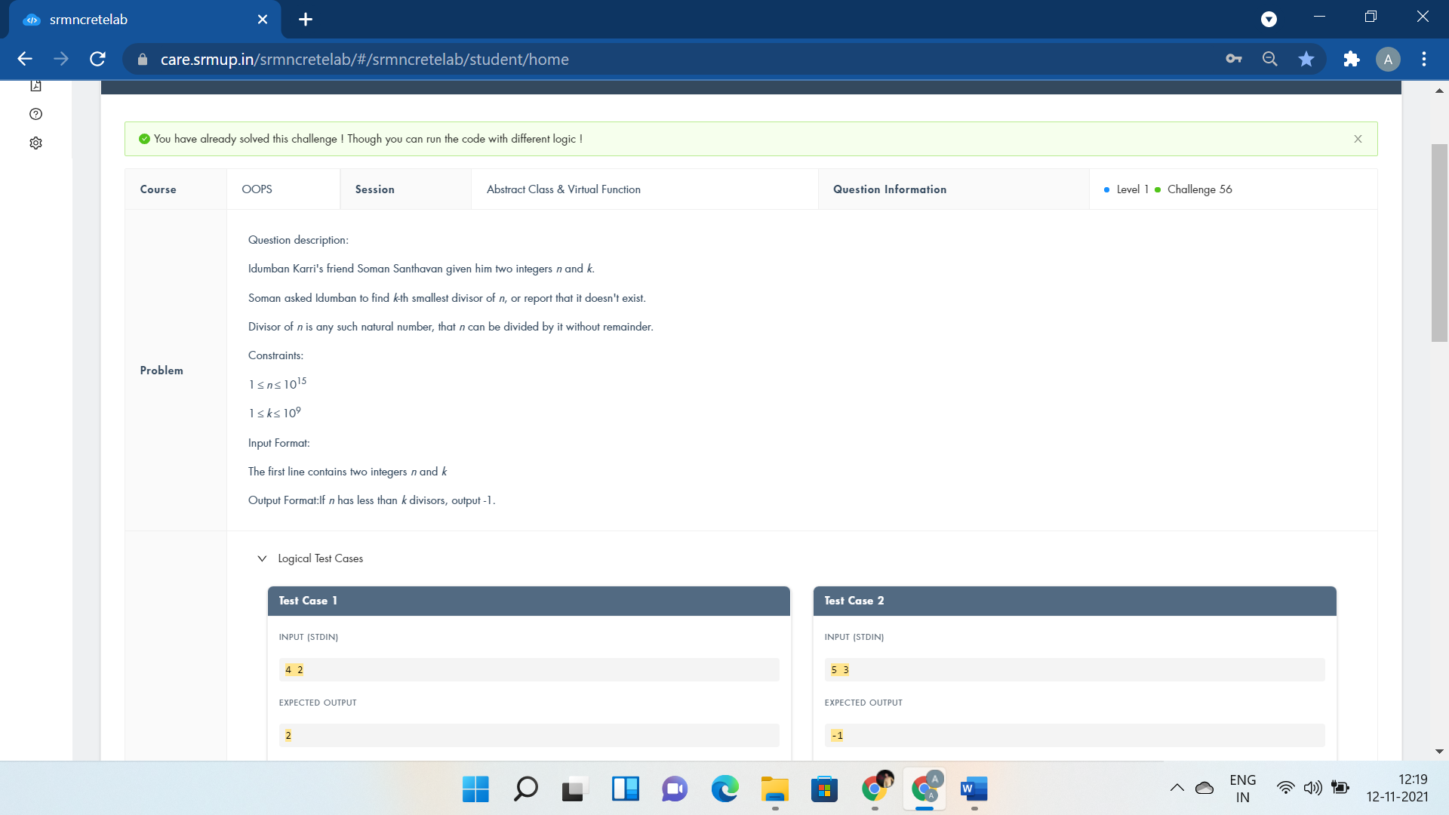

#include<iostream>

using namespace std;

class Problem {

public:virtual void Divisor()=0;

};

class Calculation:public Problem{

public:

int n,k,i;

void Divisor(){

cin>>n>>k;

}

int Display()

{

int count;

for(i=1;i<=n;++i)

{

if(n%i==0)

{

count++;

if(count==k){

cout<<i;

return 1;

}

}

}

cout<<-1;

return 1;

}

};

int main()

{

Calculation obj;

obj.Divisor();

obj.Display();

return 0;

}

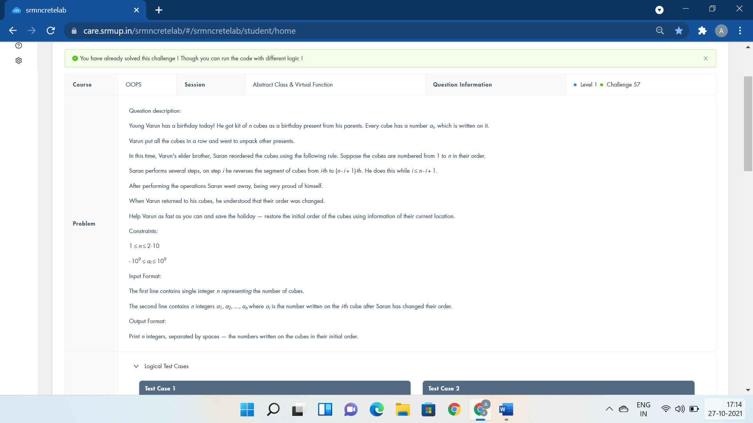

#include <iostream>

using namespace std;

class Gift {

public:virtual void Cubes()=0;

};

class Birthday:public Gift{

public:

int a[10],n;

void Cubes(){

cin>>n;

for(int i=0;i<n;i++)

cin>>a[i];

for(int i=0;i<n/2;i+=2)

/\*int temp=a[i];

a[i]=a[n-i-1];

a[n-i-1]=temp;\*/

swap(a[i],a[n-i-1]);

for(int i=0;i<n;i++)

cout<<a[i]<<" ";

}

};

int main()

{

Birthday obj;

obj.Cubes();

return 0;

}

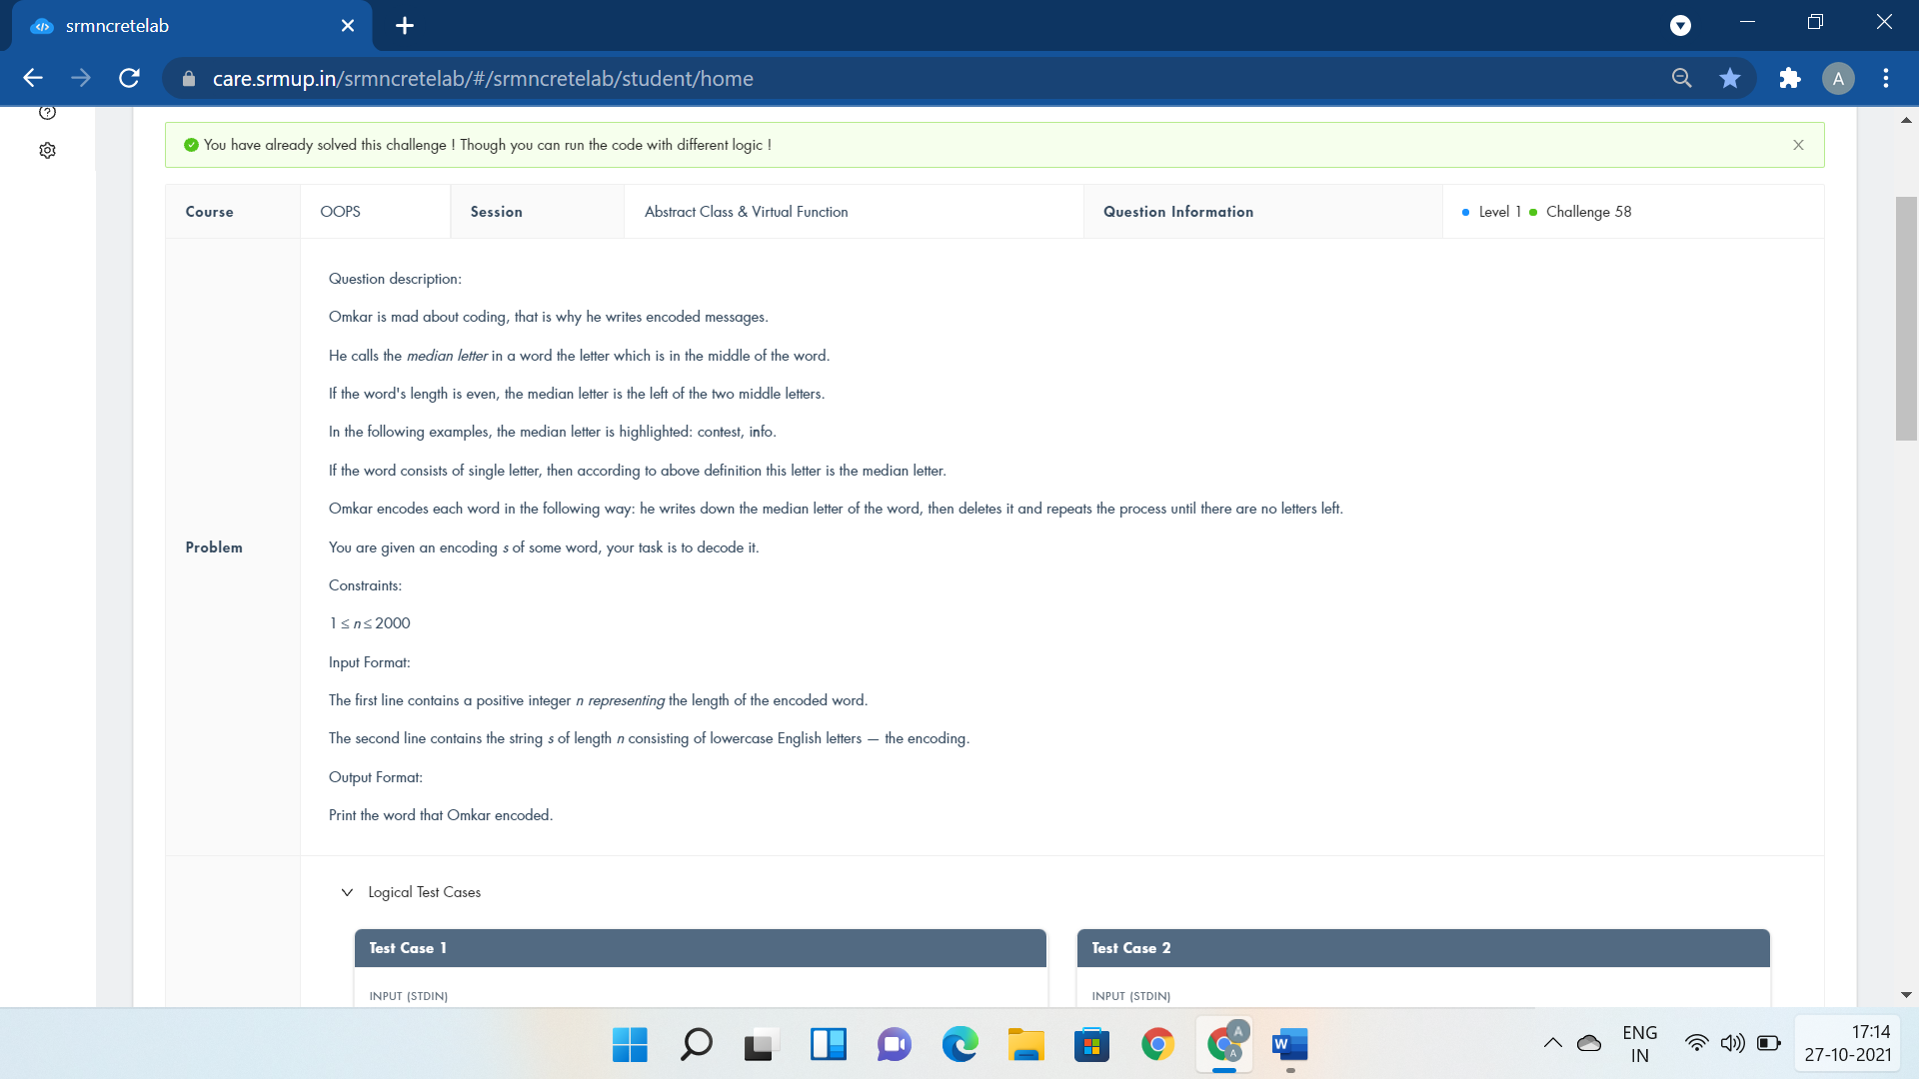

#include <iostream>

#include<string>

using namespace std;

class Decode{

public:virtual void Convert()=0;

};

class Word:public Decode{

public:

string s1,s2;

int n;

void Convert(){

cin>>n>>s1;

for(int i=0;i<n;i++){

if((n-i)%2==1)

s2=s2+s1[i];

else

s2=s1[i]+s2;

}

cout<<s2;

}

};

int main()

{

Word obj;

obj.Convert();

}

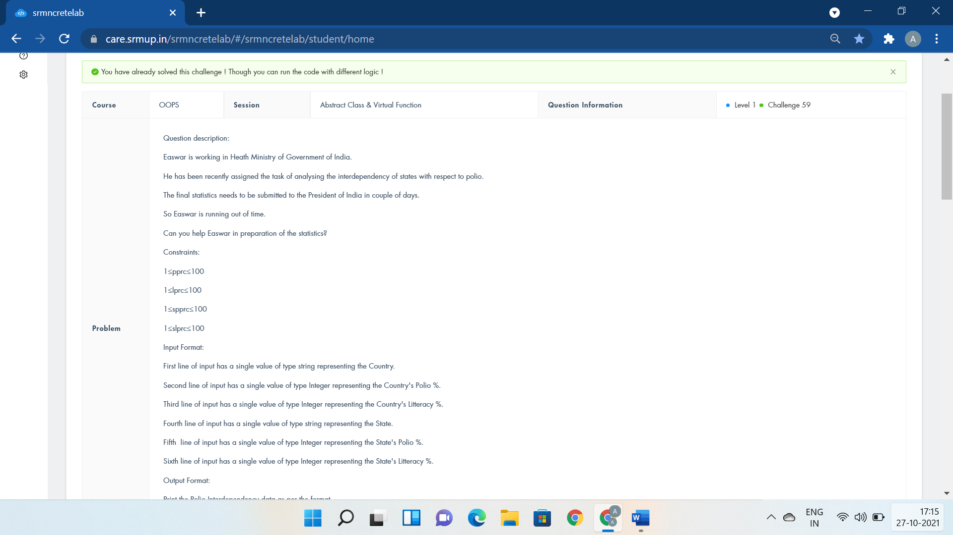

#include <iostream>

using namespace std;

class country

{

public:

virtual void getdata() = 0;

virtual void display() = 0;

};

class state:public country

{

public:

char a[20];

int b,c;

char d[20];

int e,f;

void getdata(){

cin>>a>>b>>c>>d>>e>>f;

}

void display()

{

cout<<"Country:"<<a<<endl<<"Country's Polio %:"<<b<<endl;

cout<<"Country Literacy %:"<<c<<endl<<"Interdependency Rate:"<<(float)b/c<<endl;

cout<<"State Name:"<<d<<endl<<"% of Polio of State:"<<e<<endl;

cout<<"% of Literacy of State:"<<f<<endl<<"Interdependency Rate:"<<(float)e/f;

}

};

int main() {

if(0)

cout<<"country::getdata();";

country \*o1;

state o2;

o1=&o2;

o1->getdata();

o2.display();

return 0;

}

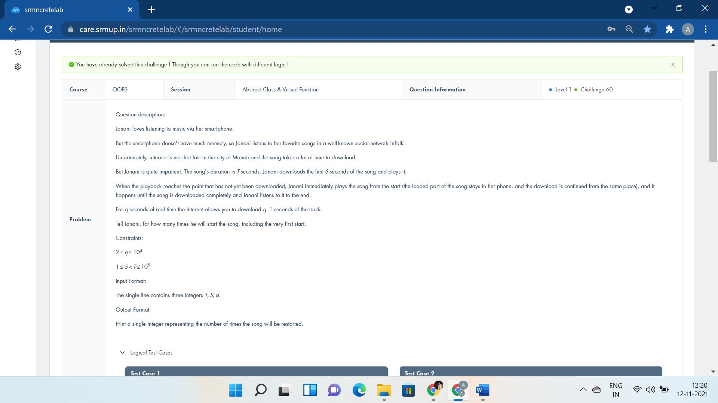

#include<iostream>

using namespace std;

class Smartphone{

public:virtual void Listening()=0;

};

class LoveForMusic:public Smartphone{

public:

int T,S,q,c=0;

void Listening(){

cin>>T>>S>>q;

while(S<T){

c++;

S\*=q;

}

cout<<c;

}

};

int main()

{

LoveForMusic obj;

obj.Listening();

return 0;

}